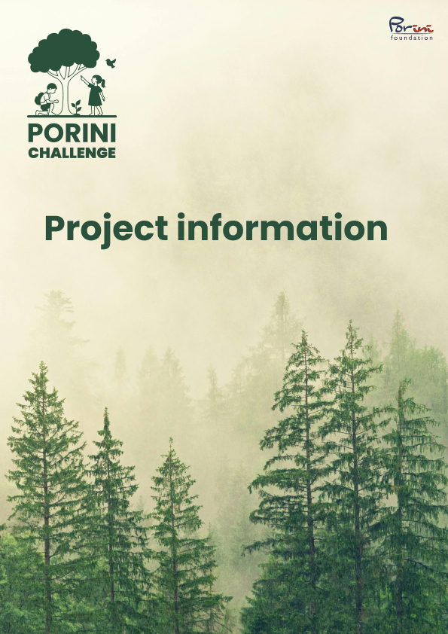

“People are only willing to protect what they know and value.”
The PORINI Challenge aims to inspire children throughout Switzerland to take an interest in nature conservation – by getting involved themselves and enjoying positive experiences of nature in their immediate surroundings.
Schools are invited to submit their existing projects, share their knowledge, and be inspired by new, creative ideas. This creates a lively exchange – with the chance to learn from each other and win one of five prize money awards worth CHF 1,000.
Together, we are building a growing network of inspiring practical examples that show that nature conservation begins where children experience what needs to be preserved.
What are the conditions of participation?
All schools or school classes in cycles 1 to 3 based in Switzerland are eligible to participate in the PORINI Challenge. Collaboration with other organizations is permitted, but the project must be carried out within the school setting.
Each project may only be submitted once. There is no upper limit on the number of projects that can be submitted. Projects that have been running for many years or are still ongoing may also be submitted. It is important that the project has actually been implemented or is in the process of being implemented. This must be documented with appropriate documentation.
How can I participate?
Together with your class or the entire school, you develop a project that protects nature in an appropriate way. You document your project and submit it by May 31, 2026, at the latest, using the online entry form on our website. https://challenge.porini.foundation/en/einreichen/
What needs to be clarified for the project submission?
- What is my project?
- How does it benefit the environment?
- What challenges were there and how were they solved?
- What materials were needed and what were the approximate costs?
- Documentation on the project
What criteria are used to evaluate my project?
- Creativity
- Innovation
- Expandability
- Benefits for the environment
What will happen to my project?
A team of teachers and conservationists will evaluate your project on behalf of the PORINI Foundation. Particularly compelling projects, including the winning projects, will be published on the PORINI Challenge website.

Possible form for parents to sign:
-------------------------------------------------------------------------------------------

PORINI Challenge consent form

Place, date

Dear parents,
In the coming weeks, our class will be taking part in the PORINI Challenge and actively engaging in environmental protection. As part of this competition, we will be developing a project as a class that will benefit nature in our local area.
During the implementation of the project, we will take photos that will be published on the PORINI Challenge website. These photos serve to showcase the commitment and creativity of the students, to illustrate the progress of the project, and to inspire other schools.
Please indicate below whether or not your child may be photographed for this project.
☐ Yes, my child may be photographed during the PORINI Challenge and the photos may be published on the PORINI CHALLENGE website.
☐ No, my child may not be photographed during the PORINI Challenge.
☐ No, my child may not be photographed during the PORINI Challenge, but photos of my child's products (e.g., drawings, crafts, construction projects) may be taken and published on the PORINI Challenge website.

Child's name: ____________________________________________________________________
Name of legal guardian: ____________________________________________________________________
Signature of legal guardian: ____________________________________________________________________
Date: ____________________________________________________________________

We thank you very much for your trust and look forward to this joint project.
Kind regards,

